Ex. No. 1 | Design A Website Using HTML5
Date of Exercise | 14/07/26
GitHub Host Link | https://pranavkrishna136.github.io/m-verse-/

Aim
To design and develop a simple yet structured HTML5-based website using various essential tags and features that demonstrate a clear understanding of semantic elements and formatting techniques.
Description
This exercise involves creating a basic website consisting of a single web page structured using HTML5. Students are expected to showcase proper usage of fundamental HTML tags and implement different types of content, including headings, images, tables, lists, hyperlinks, and comments. The webpage should visually represent the application theme (e.g., tourism, food delivery, hospital, personal blog) of the student, while effectively applying background and text colors for good design aesthetics.
Procedure:
Procedure
- Based on the theme MVerse Electronics Store, create a web application.
- Create a new HTML5 file named index.html using Visual Studio Code.
- Begin the document with the <!DOCTYPE html> declaration.
- Use the required HTML5 tags such as <html>, <head>, <meta>, <title>, and <body>.
- Inside the <body>:
  - Insert a main heading using <h1>.
  - Insert section headings using <h2>.
  - Add multiple paragraphs using <p>.
  - Create different types of hyperlinks:
    - External hyperlink using target="_blank".
    - Internal hyperlink using id.
    - Bookmark hyperlink.
    - Email hyperlink using mailto:.
    - Phone hyperlink using tel:.
    - Clickable image hyperlink.
  - Insert product images using the <img> tag.
  - Create a table to display product details.
  - Add a description list using <dl>, <dt>, and <dd>.
  - Create an ordered nested list using <ol> and <li>.
  - Create an unordered nested list using <ul> and <li>.
  - Add HTML comments for each section.
  - Use <div> tags to divide the webpage into different sections.
- Apply internal CSS to change the background color, text color, font style, borders, and table formatting.
- Ensure the HTML code is properly indented and semantically correct.
- Save the file as index.html and open it in a web browser to verify the output.

Program
<!DOCTYPE html>
<html>

<head>
<meta charset="UTF-8">
<meta name="viewport" content="width=device-width, initial-scale=1.0">
<title>MVerse Electronics Store</title>

<style>
body {
background-color: #e6f2ff;
font-family: Arial, sans-serif;
color: black;
}

h1 {
text-align: center;
background-color: navy;
color: white;
padding: 15px;
}

h2 {
color: darkblue;
}

div {
background-color: white;
border: 1px solid black;
padding: 15px;
margin: 15px;
}

table {
width: 100%;
border-collapse: collapse;
}

table,
th,
td {
border: 1px solid black;
text-align: center;
padding: 8px;
}

th {
background-color: lightblue;
}

img {
width: 180px;
height: 150px;
}

.menu {
text-align: center;
background-color: lightblue;
}

.menu a {
margin: 15px;
text-decoration: none;
color: black;
font-weight: bold;
}
</style>
</head>

<body id="top">

<!-- Header -->
<h1>🛒 MVerse Electronics Store</h1>

<!-- Navigation -->
<div class="menu">
<a href="#home">Home</a>
<a href="#products">Products</a>
<a href="#contact">Contact</a>
<a href="https://www.flipkart.com" target="_blank">Visit Flipkart</a>
</div>

<!-- Home Section -->
<div id="home">
<h2>Welcome</h2>
<p>Welcome to MVerse Electronics Store.</p>
<p>We offer quality electronic products at affordable prices.</p>
<p>Shop for laptops, smartphones, headphones and smartwatches.</p>
</div>

<!-- Featured Products -->
<div id="products">
<h2>Featured Products</h2>

<table>
<tr>
<td>
<a href="https://www.flipkart.com" target="_blank">
<img src="laptop.jpg" alt="Laptop">
</a>
<p><b>Laptop</b></p>
</td>

<td>
<img src="mobile.jpg" alt="Mobile">
<p><b>Smartphone</b></p>
</td>
</tr>

<tr>
<td>
<img src="headphones.jpg" alt="Headphones">
<p><b>Headphones</b></p>
</td>

<td>
<img src="watch.jpg" alt="Watch">
<p><b>Smart Watch</b></p>
</td>
</tr>
</table>
</div>

<!-- Product Details -->
<div>
<h2>Product Details</h2>

<table>
<tr>
<th>Product</th>
<th>Brand</th>
<th>Price</th>
</tr>

<tr>
<td>Laptop</td>
<td>HP</td>
<td>₹55,000</td>
</tr>

<tr>
<td>Smartphone</td>
<td>Samsung</td>
<td>₹20,000</td>
</tr>

<tr>
<td>Headphones</td>
<td>Boat</td>
<td>₹2,500</td>
</tr>

<tr>
<td>Smart Watch</td>
<td>Noise</td>
<td>₹8,000</td>
</tr>
</table>
</div>

<!-- Description List -->
<div>
<h2>Product Categories</h2>

<dl>
<dt><b>Laptop</b></dt>
<dd>Used for study, office work and gaming.</dd>

<dt><b>Smartphone</b></dt>
<dd>Used for communication and entertainment.</dd>

<dt><b>Headphones</b></dt>
<dd>Used to listen to music.</dd>

<dt><b>Smart Watch</b></dt>
<dd>Used to track health and fitness.</dd>
</dl>
</div>

<!-- Ordered List -->
<div>
<h2>Shopping Steps</h2>

<ol>
<li>Select Product
<ol>
<li>Choose Brand</li>
<li>Choose Model</li>
</ol>
</li>
<li>Add to Cart</li>
<li>Make Payment</li>
</ol>
</div>

<!-- Unordered List -->
<div>
<h2>Available Brands</h2>

<ul>
<li>Laptops
<ul>
<li>HP</li>
<li>Dell</li>
</ul>
</li>

<li>Mobiles
<ul>
<li>Samsung</li>
<li>Apple</li>
</ul>
</li>

<li>Audio
<ul>
<li>Boat</li>
<li>JBL</li>
</ul>
</li>
</ul>
</div>

<!-- Why Choose Us -->
<div>
<h2>Why Choose Us?</h2>

<p>✔ Genuine Products</p>
<p>✔ Affordable Prices</p>
<p>✔ Fast Delivery</p>
<p>✔ Secure Payment</p>
</div>

<!-- Contact -->
<div id="contact">
<h2>Contact Us</h2>

<p>Email:
<a href="mailto:mverse@gmail.com">mverse@gmail.com</a>
</p>

<p>Phone:
<a href="tel:+919876543210">+91 9876543210</a>
</p>

<p>
<a href="#top">Back to Top</a>
</p>
</div>

</body>

</html>
Output
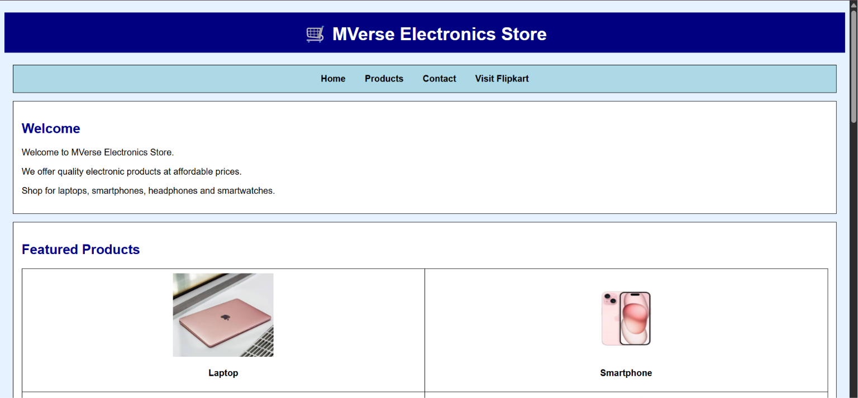
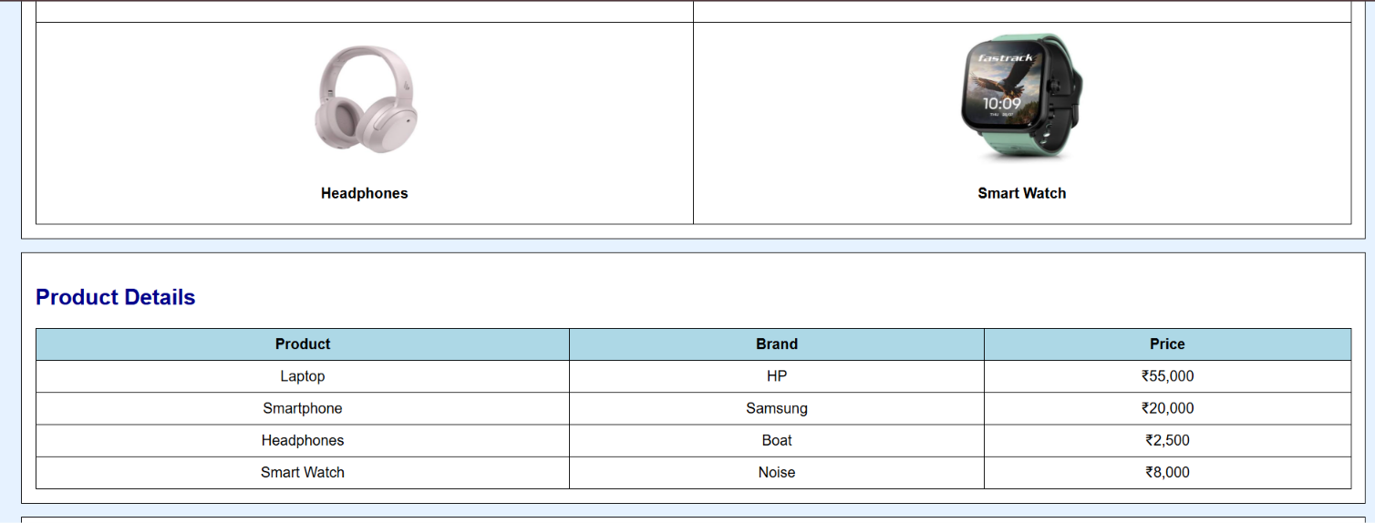
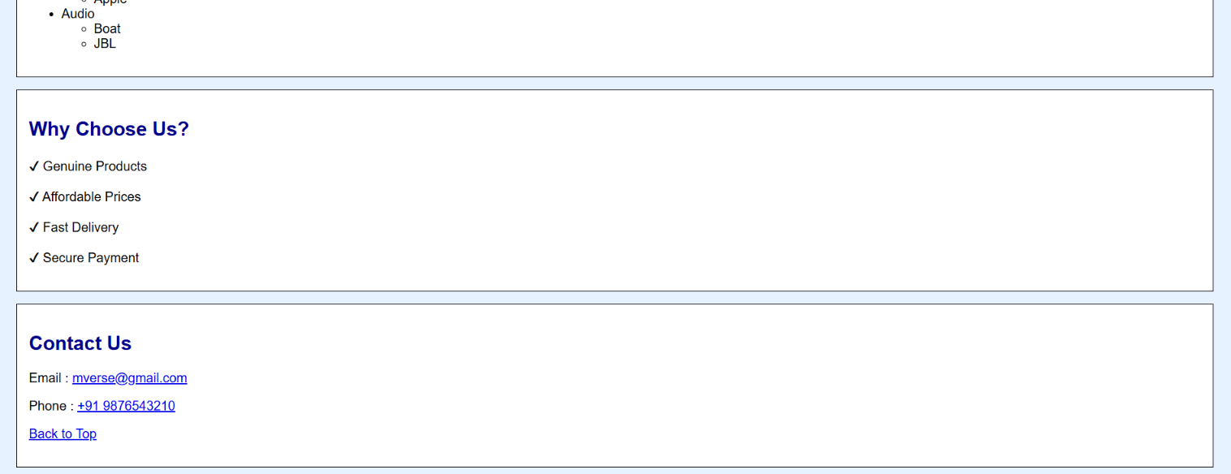
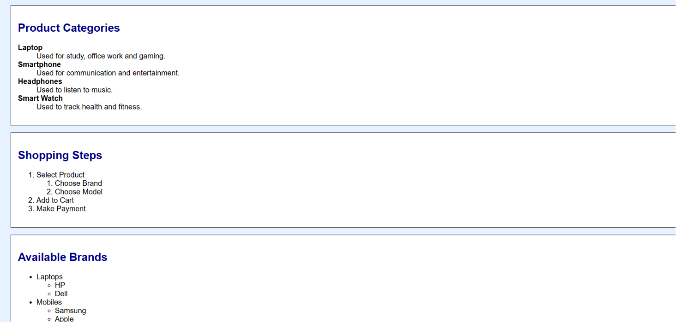

Result
The given HTML5 web page was successfully designed and executed using appropriate tags, formatting elements, and structure. The output matched the expected layout and content criteria.

